**SOLAR PANEL DUAL MANAGEMENT SYSTEM**

**AN INTERNAL FUNDED PROJECT**

***Submitted By***

**ANANDH KRUSHNA S K - 195001014 – II Year**

**DEEPANANTH K – 195001027 – II Year**

**PRAVEEN KUMAR S – 193001076 – II Year (EEE)**

**NITHISH BHARATHWAJ K R – 195001072 – II Year**



**ACADEMIC YEAR 2020-2021**

**COMPUTER SCIENCE AND ENGINEERING**

**SSN COLLEGE OF ENGINEERING, KALAVAKKAM 603110**

**January 202****1**

**SSN COLLEGE OF ENGINEERING, CHENNAI 603110**

**BONAFIDE CERTIFICATE**

Certified that this project report titled **SOLAR PANEL DUAL MANAGEMENT SYSTEM** is the *bonafide* work of **Anandh Krushna S K(195001014 – II Year), Deepananth K(195001027 – II Year), Praveen Kumar S(193001076 – II Year(EEE))** and **Nithish Bharathwaj K R(195001072 – II Year),** who carried out the project work under our supervision as an internal funded project in department of CSE during the Academic year 2019-20.

**Dr. K. Lekshmi Dr. K. K. Nagarajan**

**Supervisor Supervisor**

Associate professor Associate professor

Department of CSE, SSNCE Department of ECE, SSNCE

**Dr. Chitra Babu**

**Head of the Department**

Professor, Department of CSE,

SSN College of Engineering, Kalavakkam, Chennai - 603 110

**Place:**

**Date:**

**ACKNOWLEDGEMENTS**

I thank GOD, the almighty for giving me strength and knowledge to do this project.

I would like to thank and deep sense of gratitude to my guide **Dr. K. Lekshmi**, Associate Professor, Department of Computer Science and Engineering and **Dr. K. K. Nagarajan**, Associate Professor, Department of Electronics and Communication Engineering for their valuable advice and suggestions as well as their continued guidance, patience and support that helped me to shape and refine my work.

My sincere thanks to **Dr. CHITRA BABU**, Professor and Head of the Department of Computer Science and Engineering, for her words of advice and encouragement.

I express my deep respect to the founder **Dr. SHIV NADAR**, Chairman, SSN Institutions. I also express my appreciation to our **Dr. V. E. Annamalai**, Principal, for all the help he has rendered during this course of study.

I would like to extend my sincere thanks to all the teaching and non-teaching staffs of our department who have contributed directly and indirectly during the course of my project work. Finally, I would like to thank my parents and friends for their patience, cooperation and moral support throughout my life.

**ANANDH KRUSHNA S K PRAVEEN KUMAR S**

**DEEPANANTH K NITHISH BHARATHWAJ K R**

**ABSTRACT**

Current Solar Panel theft prevention system has limitations such as alerting the consumer even when some insignificant objects (like birds, insects) passes through the photoelectric mechanism installed to prevent the theft, not properly alerting the user about unauthorised activities. The inefficient performance of these systems may lead to theft of solar panels and loss of investment. If the above-mentioned problems are addressed, we can avoid theft of solar panel and hence can save money and prevent loss of power generated using solar panel. Currently, there is a need to check the solar panel periodically to find if there is any deposition of dust on the solar panel that causes a drop in output power. Hence, this paper proposes Solar Panel Dual Management System which can detect the unauthorised activities and also automates the detection of dust deposition on solar panel.

**TABLE OF CONTENTS**

**Abstract 3**

**List of tables 5**

**List of figures 6**

**List of abbreviations 7**

**1. Introduction 8**

**2. Literature survey 10**

**3. Solar Panel Dual Management System 12**

3.1 Problem Definition…………………………………… 12

3.2 Problem Solution...…………………………………… 12

3.3 Detailed Design ……………………………………… 13

3.3.1 Detailed Design for Theft Prevention…….….… 13

3.3.2 Detailed Design for Dust Management…...….… 14

**4. Methodology 15**

4.1 Theft Prevention………………………………………15

4.2 Dust Maintenance………………………………...…...16

**5. Implementation and Results 17**

**6. Conclusion 24**

**A Account Statement 25**

**LIST OF TABLES**

**1.1** Result of drop in output voltage due to dust deposition… 9

**2.1** Effect of Sand on Output Power…………………………11

**A.1** Account Statement ………………………………………25

**LIST OF FIGURES**

**2.1**  Graph indicating Effect of Sand on Output Power….….…11

**3.1**  Pictorial Representation for Theft Prevention System……13

**3.2**  Pictorial Representation for Dust Maintenance System.….14

**4.1** Unauthorized activity Alert Mail………………………….16

**4.2** High dust deposition Alert Mail…………………………..16

**4.3** Low power generation Alert Mail………………………...16

**5.1** Sensor Interfacing with LinkIt One Board………………..17

**5.2** Ubidots Web Server Page Containing Variables for All Devices…………………………………………………………18

**5.3** Acceleration VS Time…………………………………….19

**5.4** Dust Concentration VS Time……………………………..20

**5.5** Current VS Time………………………………………….21

**5.6** Voltage VS Time…………………………………………21

**5.7** Power VS Time…………………………………………..22

**5.8** Voltage VS Dust Concentration………………………….22

**LIST OF ABBREVATIONS**

**SPDMS** Solar Panel Dual Management System

**GDS** Grove Dust Sensor

**PCS** Particles

**CF** Cubic Feet

**LPO** Low Pulse Occupancy

CHAPTER-1

**Introduction**

About 2% of the world’s power necessity is satisfied by solar power generated using solar panel. Also, the usage of solar panels is increasing, since it is a renewable resource and also it is non-polluting power generating mechanism. Many organisations, companies and industries use solar panel since it can save a big part of expenditure for electricity. Nowadays not only organisations and industries use solar panel, but also many individuals use solar power.

The solar power is generated from the solar cells which is present in the solar panel. The solar cells are made of photo-electric cells. When sun light falls on the solar panel, the photo-electric cells present in the solar panels exhibit photo-electric effect. The photo-electric effect is nothing but the flow of electric current inside the photo-electric cell when there in an incident light which falls on them. The solar panel has many photo-electric cells, such that the output power generated is high enough.

A lot of money is invested in the process of installation of solar panel. Since it is costly, there is a main disadvantage of being stolen. This not only results in loss of investment but also results in loss of one source of power.

The pollution level is increasing day by day. The solar panel needs to be kept in well sun-light-exposed area. There are many chances of dust storm, air pollution or fog to occur in those areas where solar panel is kept. Hence, there is possibility of deposition of dust particles on the solar panel. The dust particles have the nature of reflecting the light incident on it. If those dust particles deposit on the solar panel, they reflect the sunlight which stops the light from reaching the photo-electric cells. This results in loss of output power. The drop in output solar voltage from a 12V solar panel due to dust deposition is listed in Table 1.1.

|  |  |
| --- | --- |
| **Dust concentration**  **(pcs/0.01cf)** | **Output voltage**  **V** |
| 112.784 | 9.7 |
| 225.42 | 9.5 |
| 338.353 | 9.35 |
| 451.13 | 9.26 |
| 565.92 | 9 |
| 676.73 | 8.8 |
| 920.32 | 8.2 |

TABLE 1.1: Result of drop in output voltage due to dust deposition

Solar Panel Dual Management System helps in notifying the user when there is an unauthorised activity and also notifies the user about the right time to clean the solar panel. The acceleration of the solar panel is constantly noticed using accelerometer and the user is notified when there is an unauthorised activity. The dust deposited on the solar panel is calculated in terms of concentration and the output power is also calculated. With these values the user can be notified to clean the surface of the solar panel.

CHAPTER-2

**Literature Survey**

Abhishek Rao and his team [1] had conducted a study on the effect of dust on the solar panel performance. The study is performed by plotting the I-V characteristics graph for the identical panels subjected to the same condition of isolation and ambient temperature. One of the panels had its surface covered with dust while the other had a clean dustless surface. It was found that the panel that had dust on its surface had shown a drop in the output current which is reflected to the output power of the panel.

In addition to this, Rohit Pillai and Monto Mani [2] had done some more study on the I-V characteristics graph with different types of particles and declared that the installation of solar panels is primarily influenced by the geographic location and installation design to maximize solar exposure. They concluded that the output power reduces with increase in dust deposition.

Neil S.Beattie and Nicola M.Pearsall [3] had done laboratory investigation on dust deposition on glass surface. When light is incident on the dust deposited glass surface, the intensity of light that comes out at the other side is decreased. The same phenomenon is applicable to solar panels. They found that the dust particles reflect the sunlight that is incident on them and the intensity of light photon available for solar energy conversion is low and hence the output power is decreased.

Motasem Saide and his team [4] had done experiments about the accumulation of dust on the solar panel. Under different experimental conditions, they conducted the experiments and found that the dust particles scatter the light falling on them. This reduces the efficiency of solar panels. They also said that this decrease in efficiency of solar panel due to dust deposition is appreciable different for sample panels exposed to dust for different periods. They finally concluded that this decrease in efficiency can be prevented by scheduled cleaning and suitable methods to prevent the clustering of dust on the surface of the solar panels.



TABLE 2.1: Effect of Sand on Output Power



FIG 2.1: Graph Indicating the Effect of Sand on Output Power

CHAPTER-3

**Solar Panel Dual Management System**

**3.1 Problem Definition**

Solar Panels installed in high polluted or deserted or urban regions are subjected to accumulation of dust particles and pollutants. This results in decrease in efficiency of solar panels. To increase the efficiency, the solar panel needs to be cleaned at appropriate times. The user cannot regularly check the solar panel for dust deposition and could not find the appropriate time for cleaning. Also, the solar panels are costly and it is a renewable source of electricity. They have a major disadvantage of being stolen.

**3.2 Problem Solution**

**1) Theft Prevention:** To achieve this we use the accelerometer. If the Panel moves or unauthorized activity occurs then there is change in axis value of accelerometer which will be detected by LinkIt ONE. It will process and notify the user through alert message.

**2) Maintenance Indication:** To achieve this function we use Dust, Voltage and Current Sensors. When the deposition of dust on Panel increases, the efficiency starts to reduce. This can be monitored by LinkIt ONE using the sensor values. It will update this data on web server which can be monitored to know the time for maintenance of Panel.

**3.3 Detailed Design**

**3.3.1 Theft Prevention**

The Accelerometer is fixed to back of the solar panel. This Accelerometer is interfaced with the LinkIt One Board which is linked to the web server using Wi-Fi. This setup is used to monitor any movement by unauthorized person. The Accelerometer constantly detects the acceleration of the solar panel with respect to acceleration due to gravity (g=9.8 m/s2) in all 3 axes. Whenever an acceleration is detected in any one of the 3 axes, the consumer is notified through the web server.

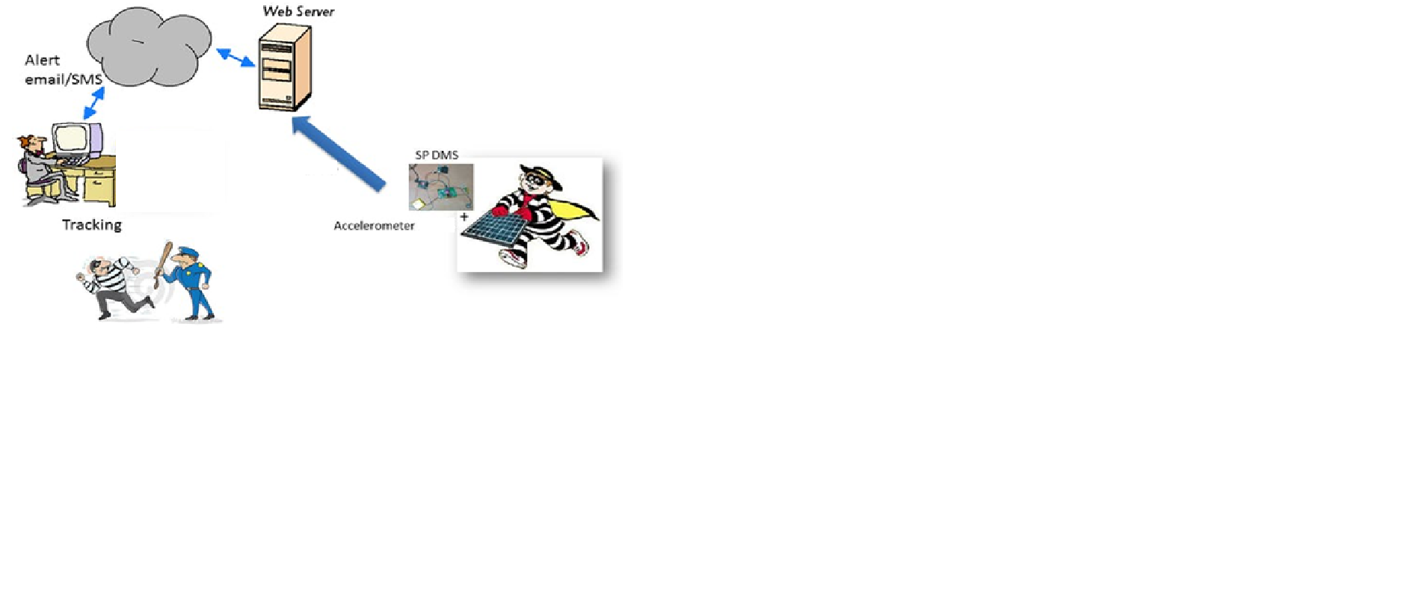

FIGURE 3.1: Pictorial Representation for Theft Prevention

**3.3.2 Dust Maintenance**

The dust, current and voltage sensors are fixed to the solar panel. These sensors are interfaced with the LinkIt One Board which is linked to the web server. This setup calculates the dust concentration and also the output power. These values are sent to the web server and can be monitored. When the dust concentration crosses a certain limit and also the output power falls beyond the threshold value, the user is notified to maintain the solar panel by cleaning it.

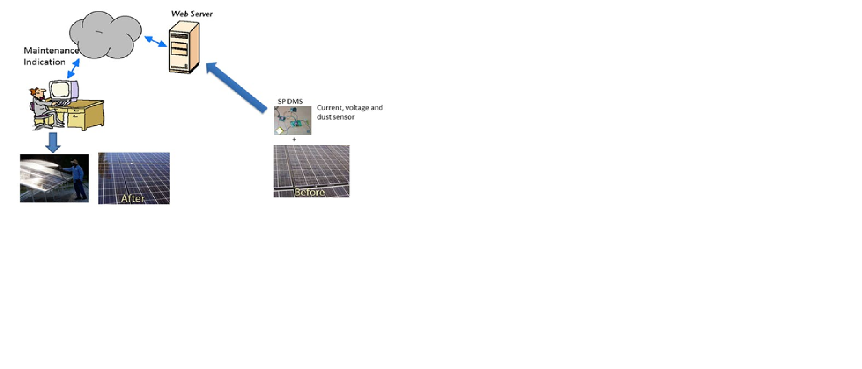

FIGURE 3.2: Pictorial Representation for Dust Maintenance

CHAPTER-4

**Methodology**

The proposed system consists of mainly two parts i.e., in the first part we monitor the position of the solar panel and directly send the data to web server. In the second part we measure the concentration of dust deposited on the solar panel and also the output power alert the consumer to clean the solar panel using the web server.

**4.1 Theft Prevention**

The Grove Accelerometer is attached to the solar panel. The Accelerometer is interfaced with LinkIt One Board, which is linked to the Ubidots web server. The Accelerometer is used to measure acceleration of the solar panel with respect to acceleration due to gravity (g=9.8 m/s2).

At first, the initial reading of the accelerometer in all three axes is noted. At a particular instance, the reading of the accelerometer is taken at that instance of time. This value is compared with the initial reading.

If there is no unauthorised activity, the solar panel has no acceleration and accelerometer does no detect any change in any of the three axes. Hence the comparison with the initial reading returns false. This result is sent to the web server to which the LinkIt One Board is linked. Since the result of comparison is false, the web server identifies no unauthorised activity and hence continues its job.

If there is any unauthorised activity, the solar panel is subjected to acceleration. This acceleration is reflected in accelerometer with a change in the values of three axes. Then these values are compared with the initial values. The result of comparison yields true which indicates the acceleration of solar panel. This result is sent to the web server. The web server detects that there is an unauthorised activity and sends the user an alert message.

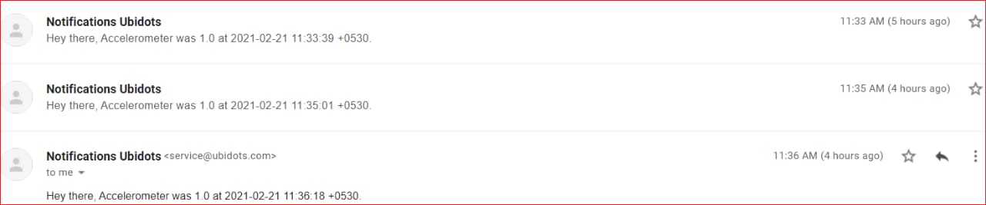

FIGURE 4.1: Unauthorized activity Alert Mail

**4.2 Dust Maintenance**

The Grove Dust Sensor, Current Sensor and the Voltage Sensors are attached to the Solar Panel. These are interfaced with the LinkIt One Board which is linked to the Ubidots web server. The dust sensor calculates Low Pulse Occupancy (LPO) time which means the time for which the dust passes through the dust sensor. From the Low Pulse Occupancy time, we indirectly calculate the concentration of dust in pcs/0.01cf (particles per hundred cubic feet). Simultaneously, the current and voltage sensors calculate the output power of the solar panel.

These values are sent to the web server to which the LinkIt One Board is linked. When the concentration of dust rises above a threshold value (1500 pcs/0.01cf), and also when the power drops beyond the threshold value (1.5 W), the user is notified about cleaning the surface of the solar panel.

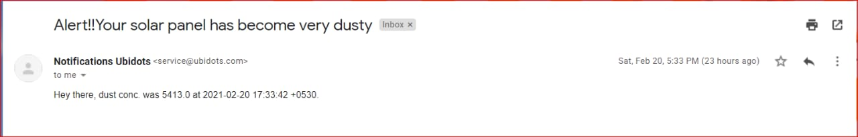

FIGURE 4.2: High dust deposition Alert Mail

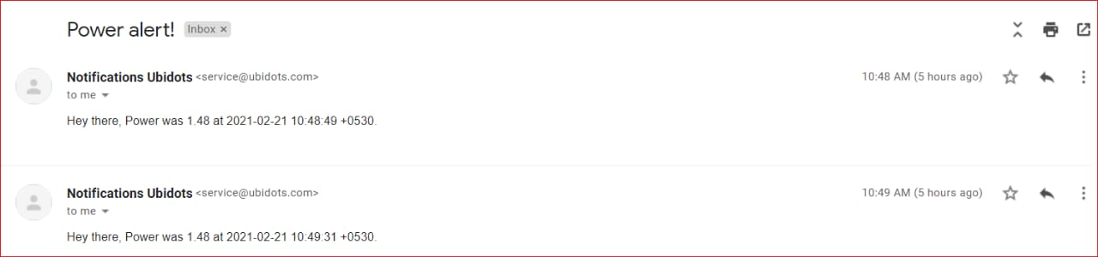

FIGURE 4.3: Low power generation Alert Mail

CHAPTER-5

**Implementation and Results**

The Various Devices that are connected and interfaced with each other can be referred from the Architecture diagram given below.

The LinkIt One Board acts as an interface between all the hardware components i.e., Solar Panel, Grove Dust sensor, Grove Accelerometer, Current sensor, Voltage sensor. This LinkIt One Board is connected to Ubidots Web Server via Wi-Fi and transmits the readings from these devices to the Server. The user can check the readings frequently in the Ubidots Web Server.

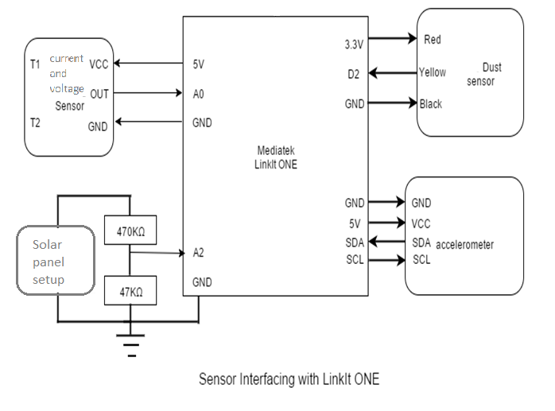

Figure 5.1: Sensor Interfacing with LinkIt One Board

The image below shows the variables created for all the devices in the Ubidots Web Server. The corresponding readings are stored and monitored from here. We can see that there are some values obtained for Current, Voltage from the respective sensors and hence Power (= V*I) is calculated from them. The Accelerometer and Dust sensor data are also listed here...

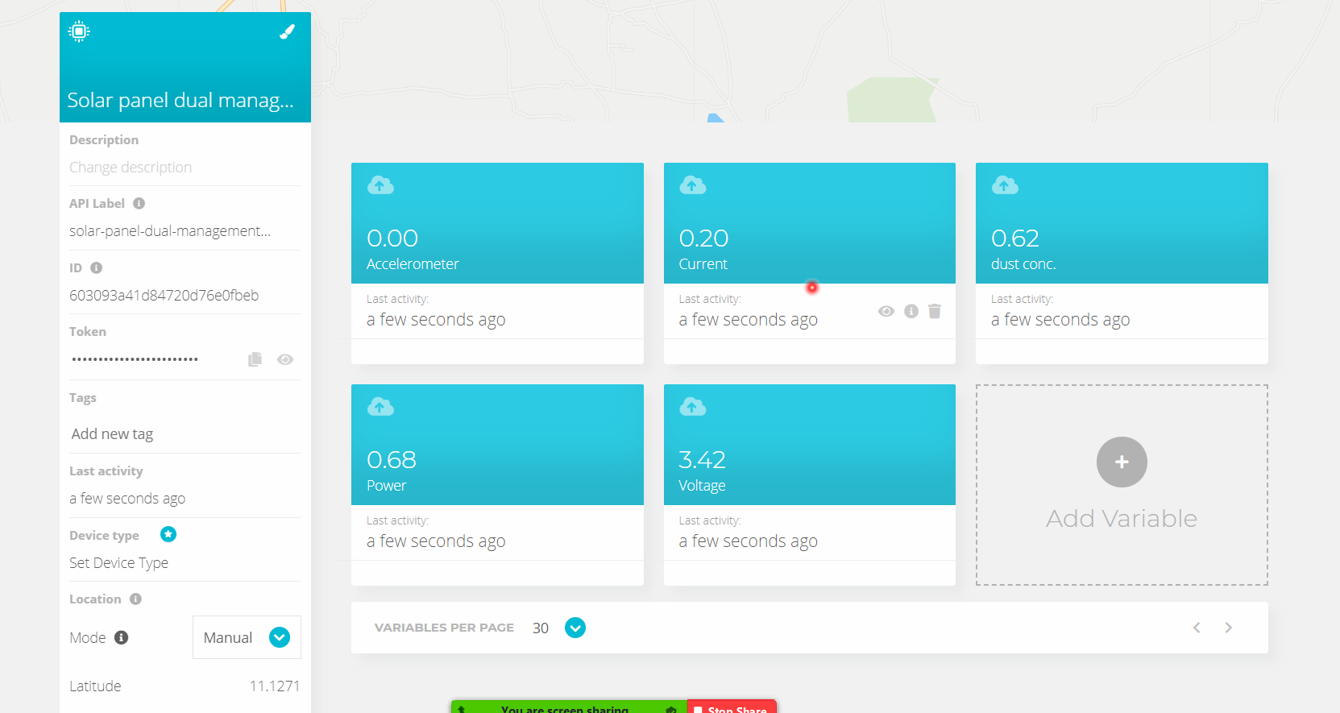

FIGURE 5.2 Ubidots Web Server Page Containing Variables for All Devices

The Graph below shows whether the solar panel is subjected to any sorts of acceleration (Any movement induces acceleration). Initially, the solar panel is static which means that acceleration is zero and hence the value sent from the Accelerometer is also 0. When the solar panel is moved, the Accelerometer is triggered and sends a value 1 which denotes movement is observed. This is evident from the Graph below where the graph grows steep immediately when movement is detected and is at 0 otherwise. This is observed for different time intervals. The user is alerted at once through an E-mail when this value becomes 0 to 1 and then he can go and check if there is any unauthorised activity.

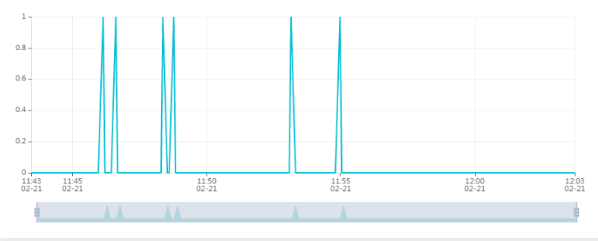

FIGURE 5.3 Graph: Acceleration VS Time

The Dust sensor collects data about the amount of dust in the surrounding air, which indirectly denotes the dust concentration on the surface of solar panel. This data is transmitted to the Web Server and a graph is plotted between concentrations of dust vs. time. The graph grows to higher levels whenever higher dust concentrations are measured and stays low when the solar panel is pretty clean. The user is notified to clean the solar panel when this value crosses 1500 pcs/0.01cf

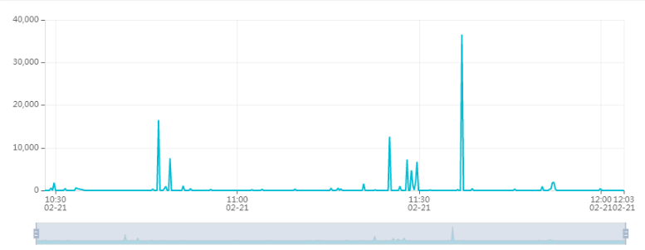

FIGURE 5.4 Graph: Dust Concentration VS Time

This graph is constructed using the values obtained from the Current Sensor and plotted with respect to time. The Current is produced from the solar panel. The measured values are sent to the web server where it is monitored.

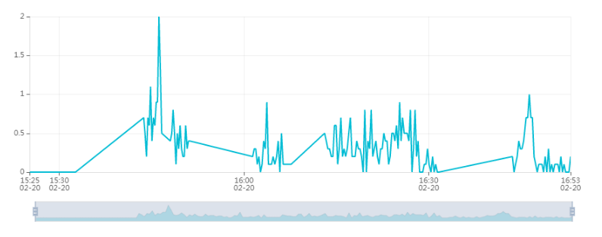

FIGURE 5.5 Graph: Current VS Time

This graph is constructed using the values obtained from the Voltage sensor and plotted with respect to time. The Voltage is also produced from the solar panel and monitored from the server.

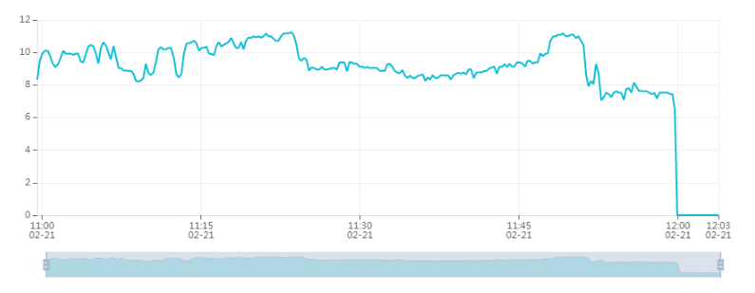

FIGURE 5.6 Graph: Voltage VS Time

Power is calculated by multiplying voltage and current values. This value is calculated for continuous values of voltage and current and is transmitted to the web server. From this observed power, a graph is plotted between power and time. The user gets notification mail when this value of power drops below 1.5watt.

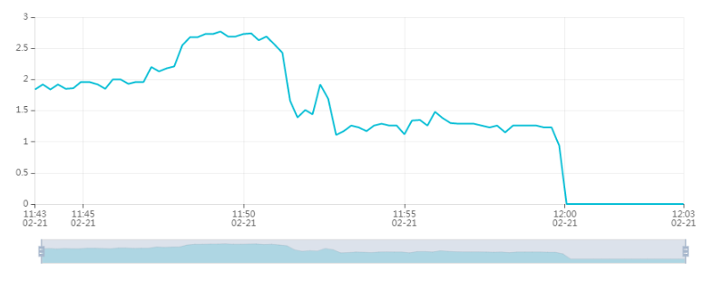

FIGURE 5.7 Graph: Power VS Time

Now we have all the values obtained from the sensors in turn from the Ubidots web server required to prove our project’s motive. We have to prove that the overall voltage generated decreases with increase in dust concentration. A graph is plotted with voltage against dust concentration which is shown below.

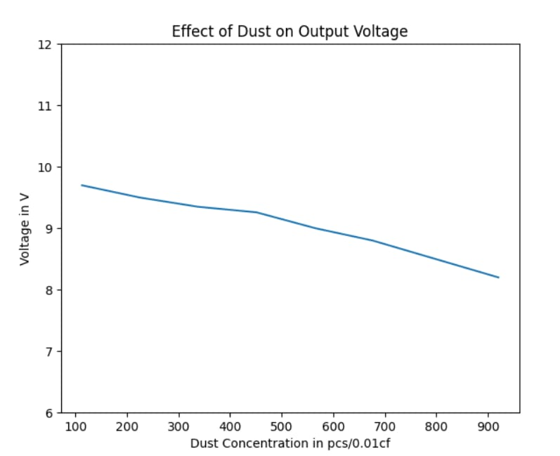

FIGURE 5.8 Graph: Voltage VS Dust Concentration

From the above graph we infer that more the dust deposition on solar panel surface is, less the output voltage is generated from the solar panel. So, dust deposition is a considerable problem that influences the efficiency of the solar panel.

* The first problem statement is unauthorized activity is not properly notified which may lead to theft of costly solar panel. Our project gives a solution that whenever movement of solar panel is detected, the user is alerted immediately using the Accelerometer attached to the solar panel.
* The second problem statement is that the solar panels are not maintained frequently to preserve the overall efficiency. Our project gives a solution that when the surface of solar panels is very dusty and therefore when the output power drops below the threshold, the user is notified.

CHAPTER-6

**Conclusion**

Our proposed project aims to design and implement a system for theft prevention and maintenance of solar panel. As the utilization of solar energy is increasing day by day, there should be an efficient benefit for it. Due to pollution, there is wastage of energy because of deposition of sand dust on solar panel. So, there is always a need to clean the solar panel over a period of time. And theft cases of solar panel are also increasing day by day. So, our project provides a solution for theft prevention for Solar Panel and also indicates the time for maintenance of the same.

APPENDIX-A

**Account Statement**

|  |  |  |  |  |
| --- | --- | --- | --- | --- |
| **S.No.** | **Product** | **Price** | **Quantity** | **Price** |
| 1. | Solar Panel | 750 | 1 | 750 |
| 2. | LinkIt One Board | 7025 | 1 | 8095 |
| 3. | Accelerometer | 1229 | 1 | 1229 |
| 4. | Dust sensor | 1060 | 1 | 1595 |
| 5. | Current sensor | 248 | 1 | 248 |
| 6. | Bread Board | 80 | 1 | 80 |
| 7. | Multimeter | 140 | 1 | 140 |
| 8. | Battery | 30 | 1 | 30 |
| 9. | Resistor | 0.5 | 10 | 5 |
| 10. | Jumper Wire | 6.25 | 40 | 250 |
| 11. | USB Cable | 40 | 1 | 40 |
| 12. | Soldering Kit | 380 | 1 | 380 |
| **Total = Rs. 12,842** | | | | |

TABLE A.1: Account Statement

**REFERENCES**

* 1. Abhishek Rao, Rohit Pillai, Monto Mani and Praveen Ramamurthy, “Influence of dust deposition on photovoltaic panel performance”, Energy Procedia, Elsevier, 54 (2014), pp. 690 – 700
  2. Monto Mani, Rohit Pillai, “Impact of dust on solar photovoltaic (PV) performance: Research status, challenges and recommendations”, Renewable and Sustainable Energy Reviews,Elsevier, 14(9), 2010.
  3. Neil S.Beattie, Nicola M.Pearsall,“Understanding the effects of sand and dust accumulation on photovoltaic modules”,Northumbria University New Castle, Elsevier, 48(2012), pp. 448 – 452
  4. Motasem Saide, Abdul Ghani Albaali, Emil Alasis, John Kaldellis, “Experimental study on the effect of dust deposition on solar photovoltaic panels in desert environment”, Elsevier,92(2016), pp.499-505.